|  |
| --- |
| Ehmad11.com |
| GANGWAY CONTROL& SECURITY SYSTEM |
| Muhammad Ahmed |

Contents

ABSTRACT 7

1. Introduction 8

a. Real world Requirement 8

b. Objectives 8

c. Project Vision 9

Vision Statements 9

Project Scope 9

2. Overall Description 10

a. Product Perspective 10

b. User Classes and Characteristics 11

Onboard crew members 11

Administrators 11

c. Operating Environment 11

d. Design and Implementation Constraints 11

e. User Documentation 11

f. Assumptions, Dependencies and Limitations 11

3. System Features 12

a. Basic Features 12

Description and Priority 12

b. Member Browsing Feature 12

Functional Requirements 12

4. Hardware Specification 14

a. Minimum Hardware 14

b. Recommended hardware 14

5. Software Requirements 15

6. External Interface Requirements 16

a. User Interfaces 16

b. Hardware Interfaces 16

c. Software Interfaces 16

Basic functionality 16

query/search system 16

Administrator interface system 16

Communications Interfaces 16

6. Other Nonfunctional Requirements 17

a. Performance Requirements 17

b. Safety Requirements 17

c. Security Requirements 17

d. Software Quality Attributes 17

7. Other Requirements 18

a. System Development Requirements 18

Description 18

Requirements 18

8. System Working: 19

9. Diagrams 20

a. Class Responsibility Collaboration 20

b. Ideal Object Model Diagrams 20

Administrator 20

Delete a Member record 21

Generate attendance reports 22

10. Datasheets 23

a. Intel 8051 Microcontroller 23

b. ULN2803 31

c. RS 232 36

d. lM 7805 42

11. Project hardware schematics 46

a. Serial interface 46

MAX232 Serial level converter 46

Schematic 47

Simple 5V power supply for digital circuits 48

Other output voltages 49

12. Operational Modes 50

a. Normal Mode 50

b. Emergency Mode 50

13. Application flowchart 51

14. Application Architecture 52

A. Hardware 52

Hardware Component 52

Microcontroller: 52

ULN2803 (Current buffer IC) 53

MAX 232 54

LM7805 VOLTAGE REGULATOR 54

PC 55

5. Algorithms 57

a. Application Algorithm 57

Implementation: 58

B. VeriFinger algorithm 58

C. Process flow 59

6. Database 60

1. Tables 60

Crew 60

Ranks 60

TimeLog 61

appSetings 61

2. Entity Relationship Diagram 62

3. Fingerprint enrollment/verification module 63

7. Class diagram 64

Dataset 72

8. Screenshots 73

a. Main window 73

User Information Form 74

Signing IN/Out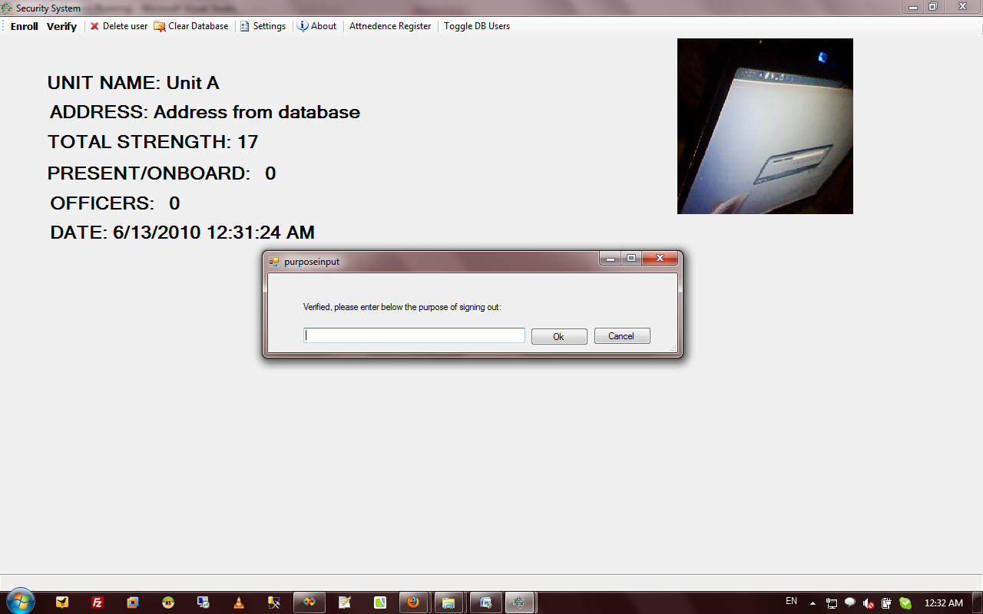 75

Administration window 76

b. Attendance report 77

9. Testing and Implementation 77

10. Conclusion 78

11. References 79

12. APPENDICES 80

APPENDIX A 80

MICROCONTROLLER CIRCUIT DIAGRAM WITH PORTS 80

Serial Interfacing 81

APPENDIX C 82

STATEBOARD CODE (ASSEMBLY LANGUAGE) 82

APPENDIX D 85

Block Diagram 85

# ABSTRACT

Engineering is not only a theoretical study but it is a implementation of all we study for creating something new and making things more easy and useful through practical study. It is an art which can be gained with systematic study, observation and practice. In the acadamic curriculum we usually get the theoretical knowledge of industries, and a little bit of implementation knowledge that how it is works? But how can we prove our practical knowledge to increase the productivity or efficiency of the industry?

Gangway is the most accessed part of any Naval Ship. Every person whether on ship or shore, has to go across it while wishing to go on board or off board. Therefore, a proper record has to be kept of all persons going across it in order to maintain the safety of the ship and its surroundings. Nowadays, a common practice in PN is that the log book or the gangway is maintained in manuscript which is being maintained by the duty staff on gangway.

Due to the deteriorating situation of law and order in the country, security practices have increased tremendously. It has increased time consumption at the security checkpoints due to which precious time and energy is wasted, life of sentries deployed at the security check point is always at very high risk due to high vulnerability and being first line of defense. The record keeping of personnel entering and leaving the unit is generally kept in manuscript which can have many loop holes. The state boards in every unit are completely dependent on being maintained by staff on duty and often are not timely maintained.

# Introduction

This document describes the functionalities of the GANGWAY CONTROL& SECURITY SYSTEM version 0.1. Real world requirements and system objectives are briefly summarized followed by detailed description of the system’s scope, vision, use case, features and other related requirement issues. This document should be referred as functional model of the system for first final release. Software application is in short, special purpose security software developed for navy ships. The application enrolls officers; shows number of people on board and keep record of their sign-in/sign-out timings by using fingerprint device as well as takes pictures captured by stationary camera on specific events.

## Real world Requirement

Nowadays, due to the security concerns worldwide, the cost of a general security systems have rocketed. The costs of security devices have raised as well as the most expensive item in the system, the software part, have mounted very high. Generally, software for monitoring the entry exit points costs more than 100,000 Rs. Therefore, our main aim was to design a cost effective gangway control system with effective add-ons related to the naval environment.

## Objectives

The objectives of this project are the following:

• The system will control the entry / exit of the gangway by means of finger print detection

• The system will automatically capture the picture of the person using the thumb detector

• A record of all the personnel enrolled or entering as guests will be maintained

• An alarm will be sounded once any negative impression will be used more than 3 times

• State board placed on the gangway will automatically be maintained by the system updating the state of senior officers on the ship

• The state of Ships Company will be readily available to the captain at any time

• The profile of any officer or sailor with respect to the duty hours and entry/exit timings will also be maintained and will be readily available to the Captain

## Project Vision

### Vision Statements

The goal of the site is to simplify online file storage, replace FTP and allow users to access files from any computer, phone or mobile device. It will enable users to share any digital file including images, audio, video, software and documents with co-workers, friends, and family. Each person will get their own login and storage space. Our website will require any existing web browser to work.

### Project Scope

This project designs and implements GANGWAY CONTROL& SECURITY SYSTEM to fulfill all the vision statements. Supported by a well-designed database, all available data and information is integrated together and can be accessed easily through a single point by administrators. System provides both member and administration interfaces with the latter used for administration purposes. If time permits, more features will be added to the system.

# Overall Description

## Product Perspective

GANGWAY CONTROL& SECURITY SYSTEM is a desktop application executing over dotnet framework and connected to MS Access database. As shown in Figure 1, system accepts and processes requests from two patrons: end crew members and system administrators. The system is expected to have a user interface for members to log into and sign out. It also has an authorization based interface for administrators. Its final release has merits of being efficient, easy and effective.

**Administrator**

**Members**

Sign IN/OUT

Manage the Whole system

Information

updates

Identity verification

**MS Access Database**

**Fingerprint device database**

**Figure 1: Context diagram**

## User Classes and Characteristics

### Onboard crew members

A member is any person who has his/her own valid identity and can step into ship. He/she can be an officer, sailor or citizen.

### Administrators

An administrator may be a dedicated staff whose responsibility is managing system’s back-end databases. They may wish to update/add/delete any information in existing members’ database. They can also view reports about members, attendance registry or any

## Operating Environment

OE-1: The application system is executable on any windows machine(XP or newer) with dotnet framework installed.

OE-2: The software works with MS ACCESS database management system.

## Design and Implementation Constraints

CO-1: The system database design is based on ER modeling which has been transferred to database schema.

CO-2: All code is as neat as it can be.

CO-3: We have managed to successfully complete the project within the tight budget (Approx. 20K Rs.), so it is cost effective as it should be.

## User Documentation

UD-1: Final release can be accompanied with a user guide to inform new users how to use FHSS.

UD-2: The system is designed as user friendly as possible.

## Assumptions, Dependencies and Limitations

AS-1: System administrators are assumed to have knowledge about computer systems.

DE-1: A high performance PC and Cool environment.

LI-1: The fingerprint device is little slow for verification. A better device can handle this issue.

# System Features

## Basic Features

### Description and Priority

The basic functionalities have been stated below:

**Functional Requirements**

|  |  |  |
| --- | --- | --- |
| **REQ #** | **Description** | **Priority** |
| **REQ-1** | The members’ records can be add/accessed/delete and modified by administrators | [Priority = High] |
| **REQ-2** | The administrators are able to search, sort and filter results | [Priority = High] |
| **REQ-3** | Members are able to sign in/out | [Priority = High] |
| **REQ-4** | Automatically maintained digital attendance registry to be accessed by administrators | [Priority = High] |
| **REQ-5** | Additional reporting features | [Priority = Normal] |
| **REQ-6** | System shall handle emergency state | [Priority = Low] |

## Member Browsing Feature

After a user performs a search, their search results are displayed. The object of this feature is to display the files which closely match the desires the user expressed during the search.

### Functional Requirements

|  |  |  |
| --- | --- | --- |
| **REQ #** | **Description** | **Priority** |
| **REQ-1** | The members’ records can be add/accessed/delete and modified by administrators | [Priority = High] |
| **REQ-2** | The administrators are able to search, sort and filter results | [Priority = High] |
| **REQ-3** | Members are able to sign in/out | [Priority = High] |
| **REQ-4** | Automatically maintained digital attendance registry to be accessed by administrators | [Priority = High] |
| **REQ-5** | Additional reporting features | [Priority = Normal] |
| **REQ-6** | System shall handle emergency state | [Priority = Low] |

# Hardware Specification

## Minimum Hardware

* Any PC capable of running windows XP or higher
* Cross match verifier 300 Fingerprint device (or any other model from same manufacturer)
* Any camera attached with system
* Hardware component

## Recommended hardware

* **OS:** Microsoft Windows XP, Windows Vista and Windows 7
* **Processor:** Intel Pentium 4 3.2 GHz or AMD Athlon 64 3200+ processor or better supported
* **Memory:** 1 GB RAM
* **Hard Drive:** 12GB of free hard drive space
* **Hardware component**

# Software Requirements

* Dotnet framework
* MS ACCESS
* VeriFinger 6.2 libraries

# External Interface Requirements

## User Interfaces

1. The system shall provide help (explanation) explain how to use that major features.
2. The GANGWAY CONTROL& SECURITY SYSTEM permits complete navigation and pass all usability and accessibility tests.

## Hardware Interfaces

Neat and clean fingerprint scanner surface is must for correct verification

## Software Interfaces

### Basic functionality

The system provides basic interface like windows operating system to its users with all navigation and features.

### query/search system

Members and other information is easily searchable in less time using labels system. Queries should be entertained as soon as possible.

### Administrator interface system

The administrator interface system communicates with database system through a programming interface for the following operations.

1. Add edit delete members’ information
2. View digital attendance registry
3. Access and view snapshots of unusual activities
4. Reporting features
5. Camera view

### Communications Interfaces

CI-1: Administrators should be notified for any usual/unusual activity.

# Other Nonfunctional Requirements

## Performance Requirements

PE-1: The system shall accommodate one user at a time effectively.

PE-2: Responses to queries takes no longer than 10 seconds to load onto the screen after the user submits.

PE-3: The administrators should be notified for every usual or unusual activity.

## Safety Requirements

SR-1: LCD radiations.

## Security Requirements

SE-1: No member can log in to the system for their own information and modification but administrators.

SE-2: The system shall permit only authorized members who are on the list of authorized Menu Managers to do administrator’s task.

SE-3: The system shall permit members perform all of their tasks at ease.

SE-4: The CPU having database should be placed at safe and secure place.

## Software Quality Attributes

Availability-1: The system shall be available to users most of the time and should be available to administrators all the time.

Robustness-1: The system can handle any unusual physical or software activity.

Consistancy-1: The most updated information should be delivered to any following queries.

# Other Requirements

## System Development Requirements

### Description

This section describes what resources are utilized in the development and use of the software.

### Requirements

|  |  |
| --- | --- |
| **Req #** | **Description** |
| **REQ-SR1** | The database system in use is MS ACCESS. |
| **REQ-SR2** | The code is in C#. |
| **REQ-SR4** | Our development environment is visual studio 2008. |
| **REQ-SR5** | Dotnet framework is being used. |
| **REQ-SR7** | We may still make changes to any of the above system requirement at any time and for any reason. |
| **REQ-SR8** | A powerful and capable PC. |

# System Working:

The working of the project is all based on the practical application of entry/exit from the gangway of a ship. Therefore, there are many situations which will have to be catered and worked on in order to make this project a success. Let us suppose that there is a person entering the ship, therefore he will be required to place his thumb of the detector for verification. If he belongs to the ship and his impression is already enrolled, green signal will be given to him for access in to the ship. In the mean time, his picture will be taken and the picture along with the time and date will be updated in his profile in the computer database. The database will also update the ships state accordingly. Now, if the person is not enrolled, the he will be asked three times, if still not enrolled, then alarm will be sounded and the gangway staff will take over. If he will be a guest, his impression will be entered in the guest profile by the gangway staff.

Same procedure will be observed once someone will be leaving the ship.

# Diagrams

## Class Responsibility Collaboration

|  |  |
| --- | --- |
| **Object Name:** Member | |
| Behaviors and Responsibilities | Collaborators |
| Store Member record | Administrators, officers |
| Retrieve data of Member from Database |
| Search for a record |
| Modification of Member record |

## Ideal Object Model Diagrams

### Administrator

#### Request to add a new Member

Add Member Button

Member Table

Addition

Add Member form

Administrator

#### Modify a Member record

Modify Member Button

Searches

Member table

Administrator

Modify Member Form

Modifies

### Delete a Member record

Delete Member Button

Searches

Member table

Administrator

Delete Member Form

Delete

### Generate attendance reports

Member Report Button

Member table

Searches

Administrator

Generate Member Report Form

# Datasheets

## Intel 8051 Microcontroller

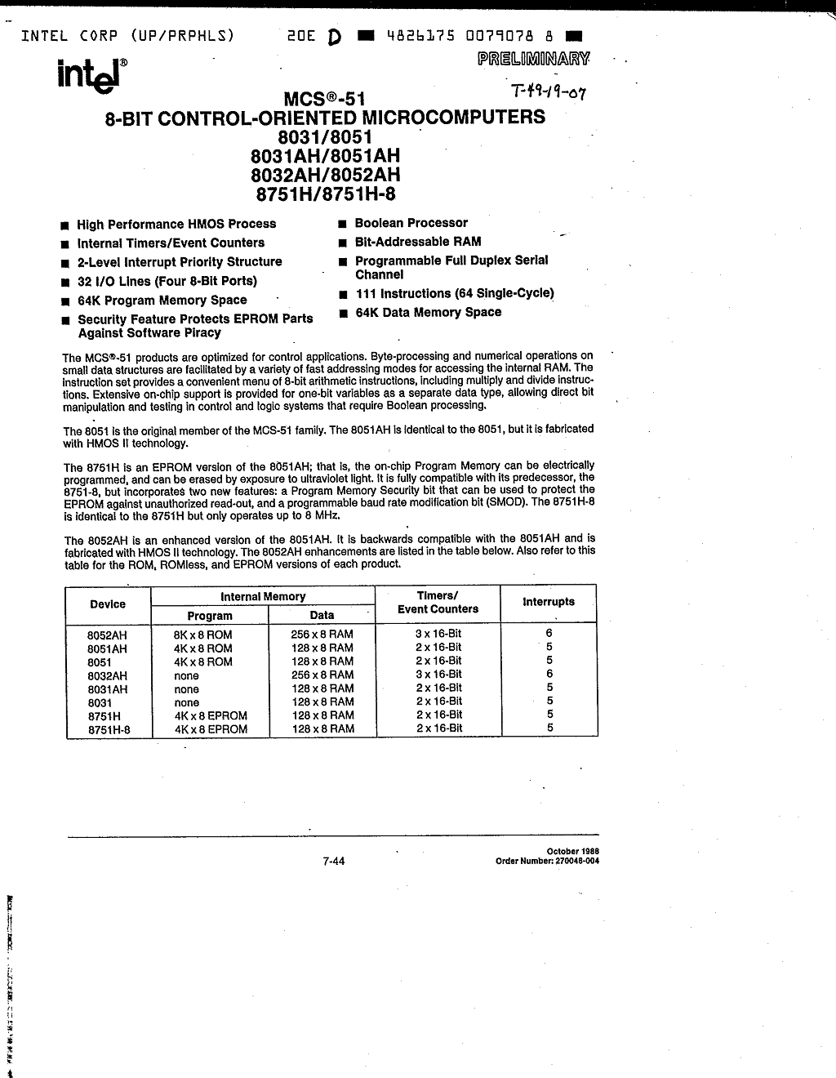

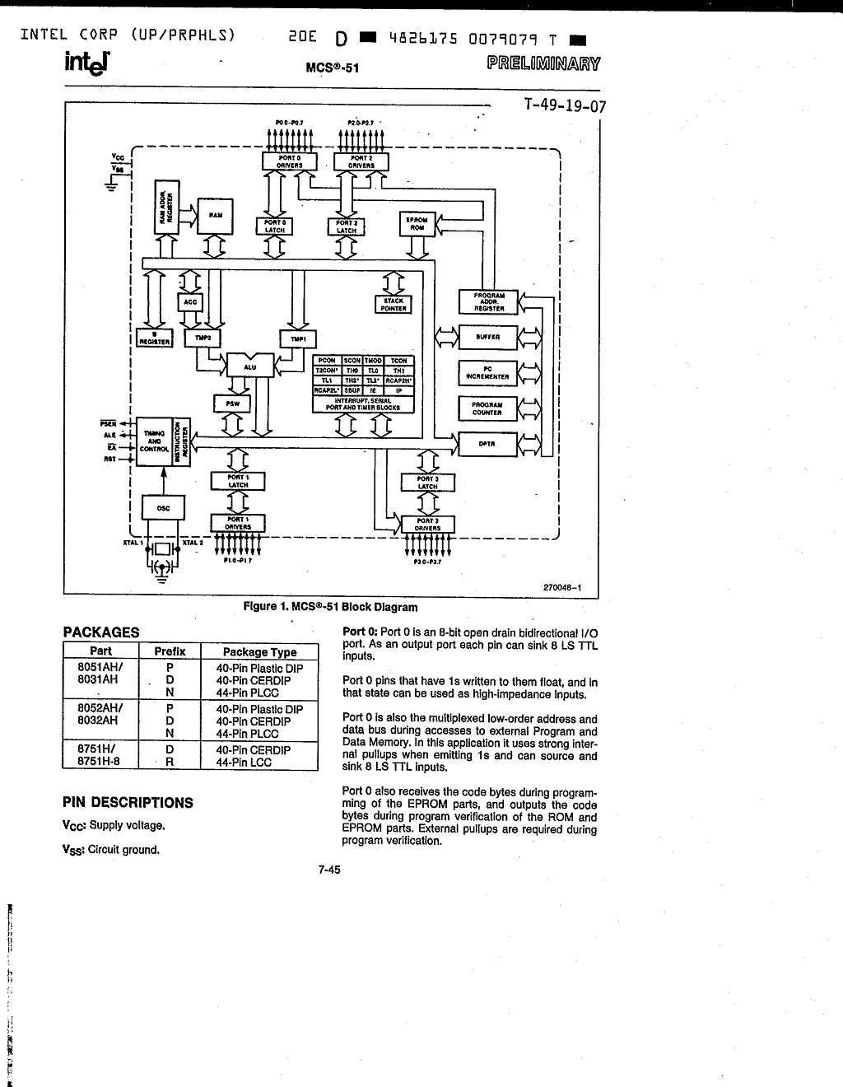

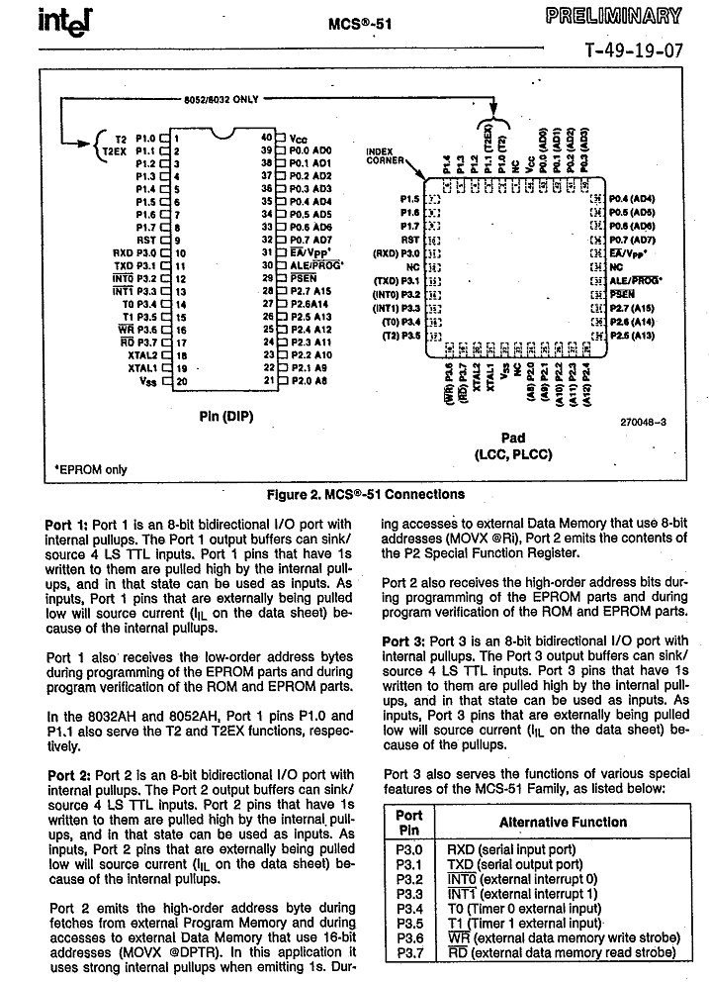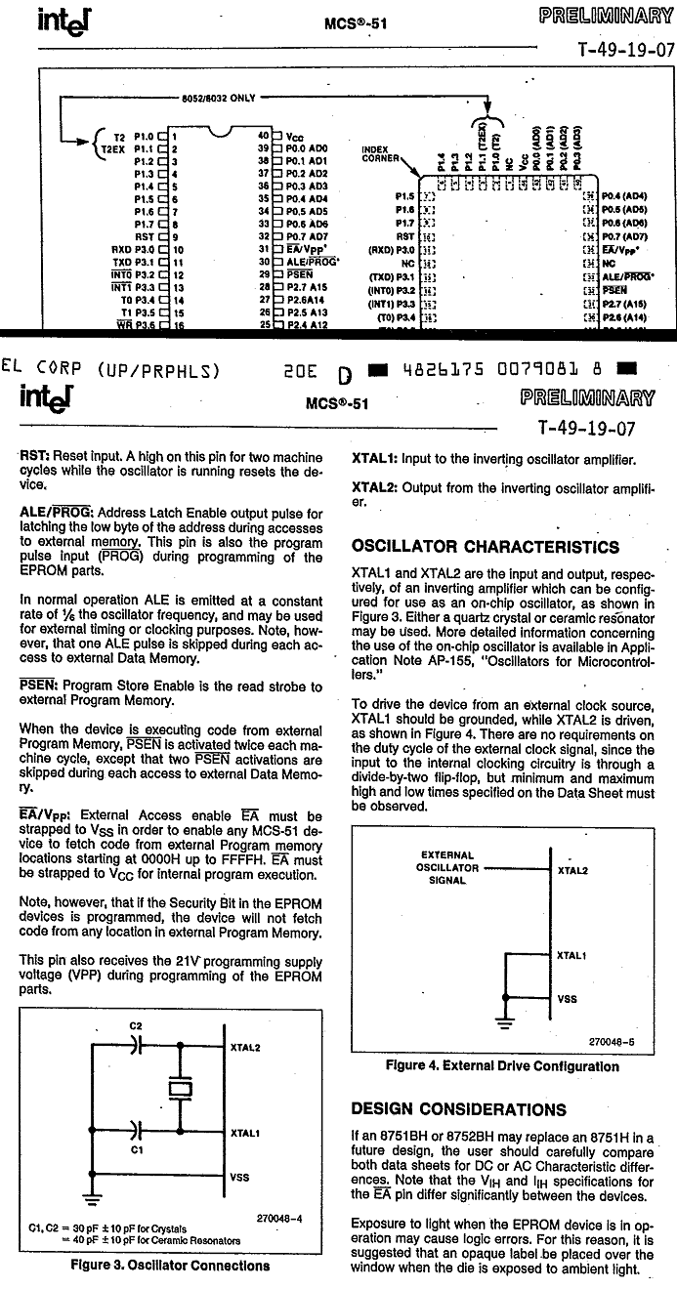

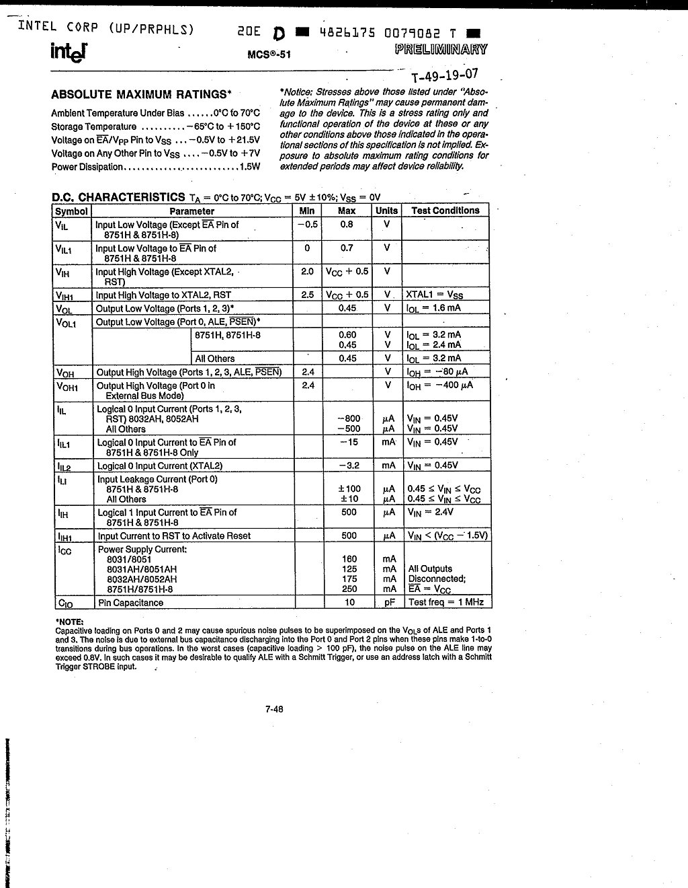

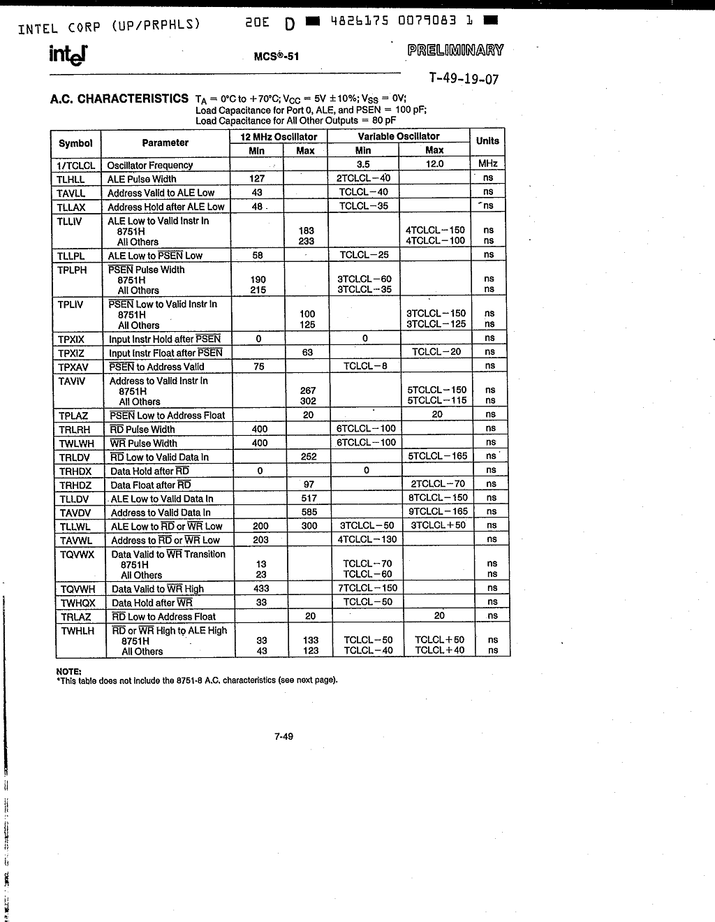

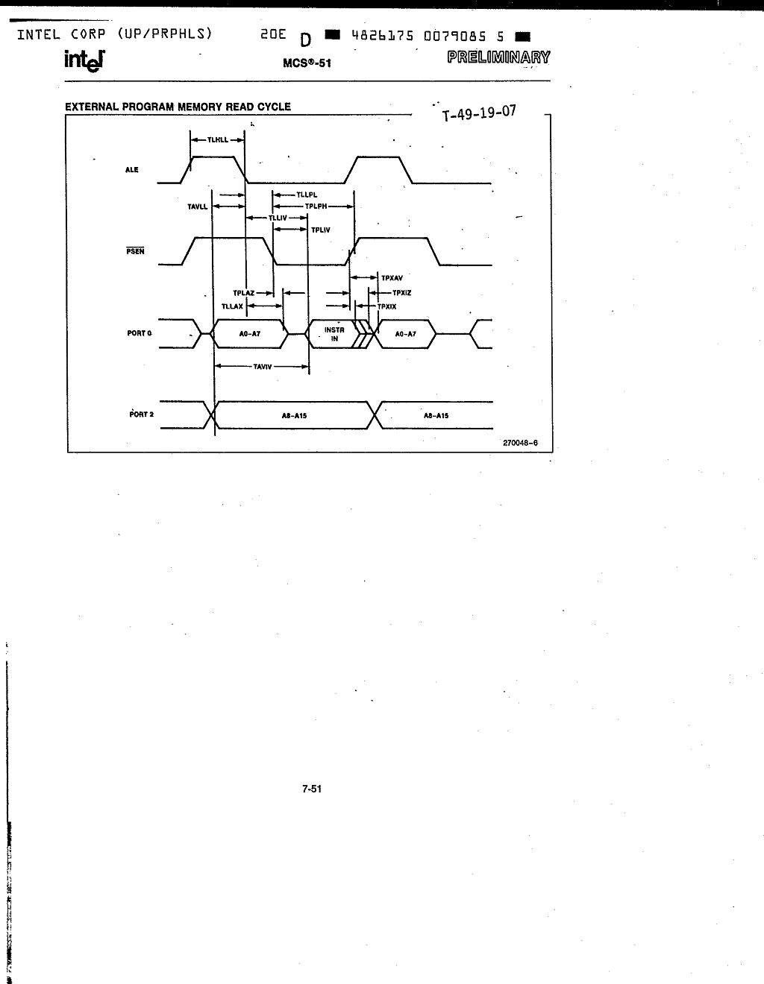

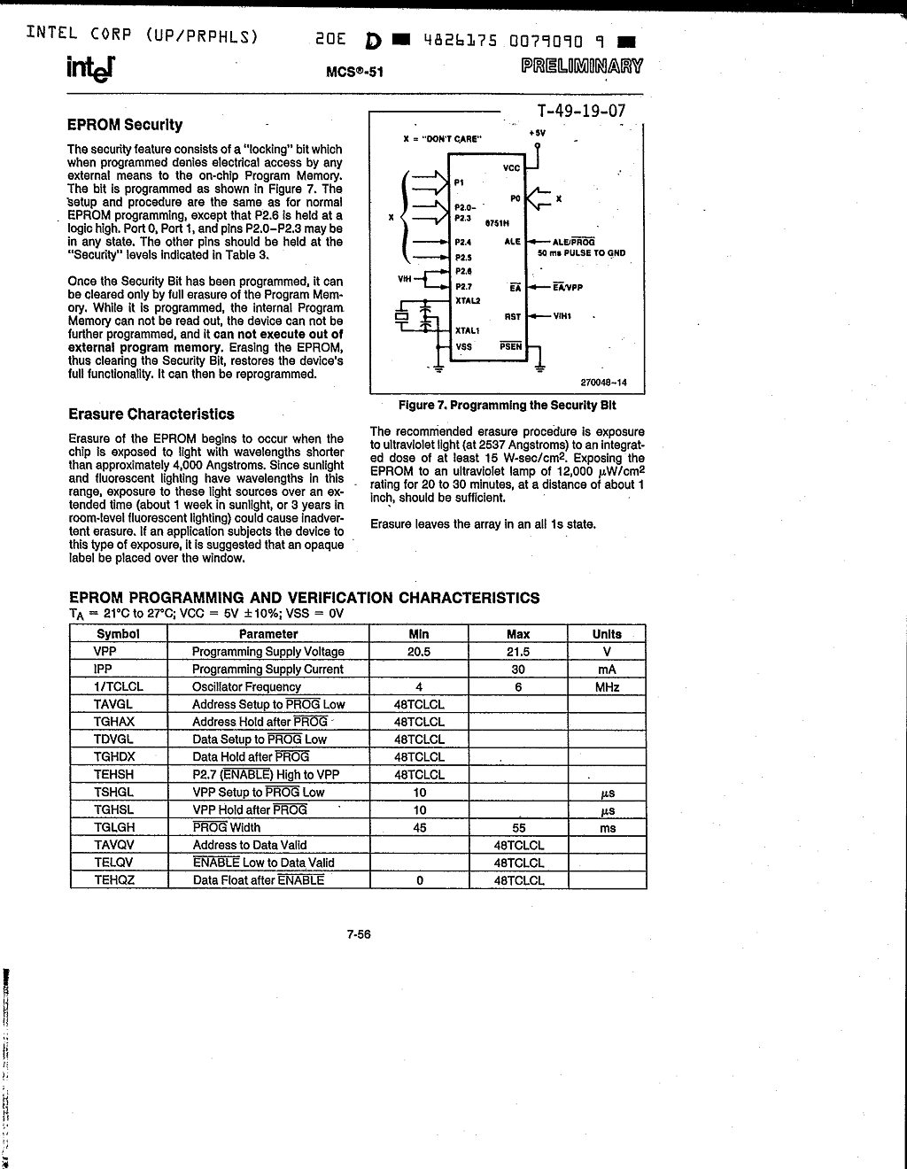

## ULN2803

The eight NPN Darlington connected transistors in this family of arrays are ideally suited for interfacing between low logic level digital circuitry (such as TTL, CMOS or PMOS/NMOS) and the higher current/voltage requirements of lamps, relays, printer hammers or other similar loads for a broad range of computer, industrial, and consumer applications. All devices feature open–collector outputs and free wheeling clamp diodes for transient suppression. The ULN2803 is designed to be compatible with standard TTL families while the ULN2804 is optimized for 6 to 15 volt high level CMOS or PMOS. MAXIMUM RATINGS (TA = 25°C and rating apply to any one device in the package, unless otherwise noted.)

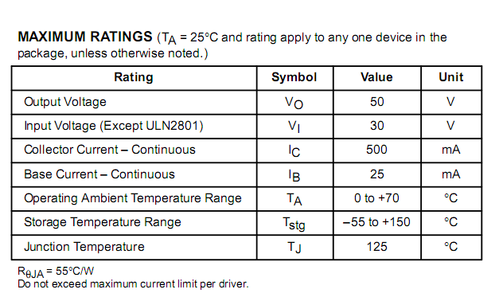

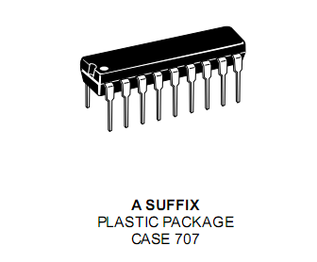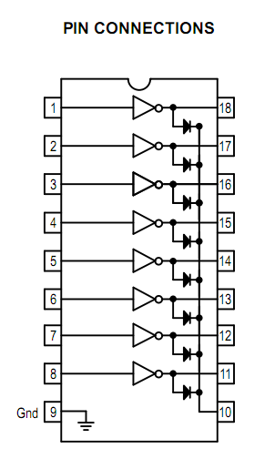

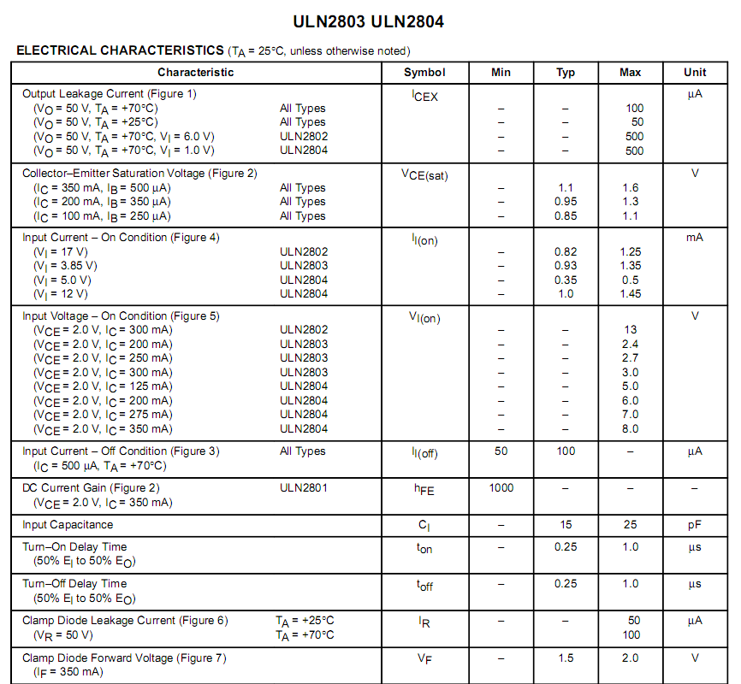

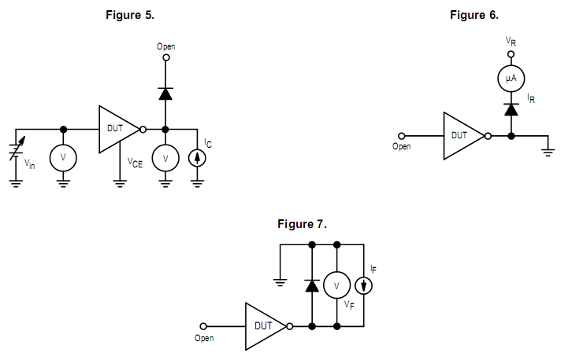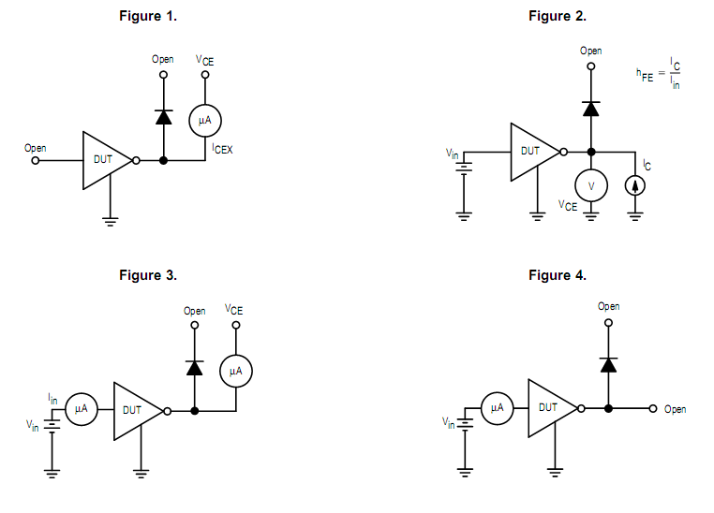

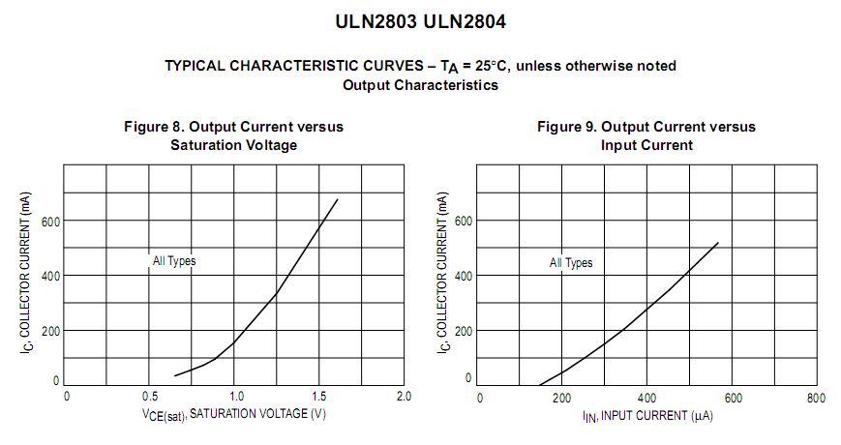 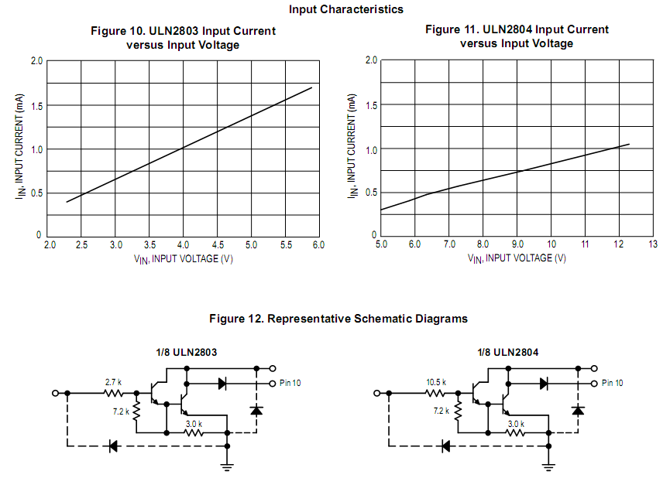

## RS 232

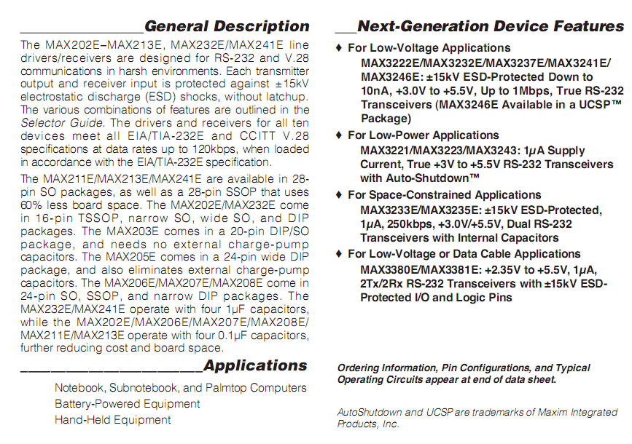 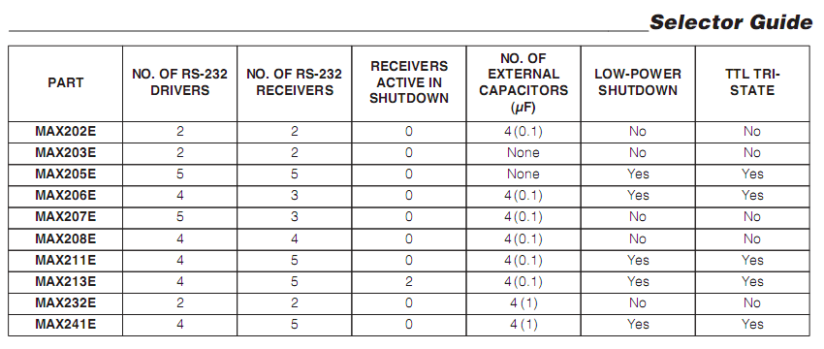

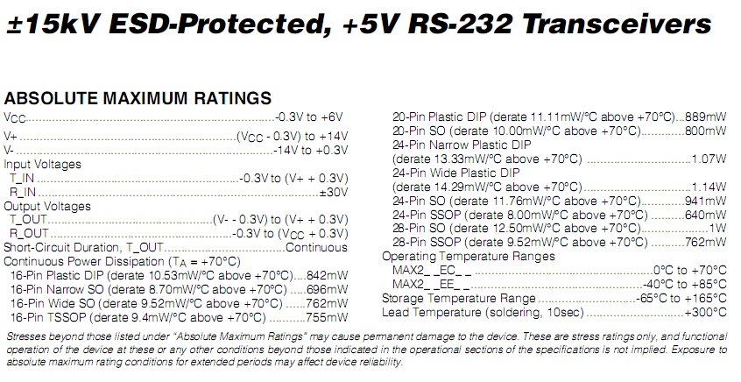

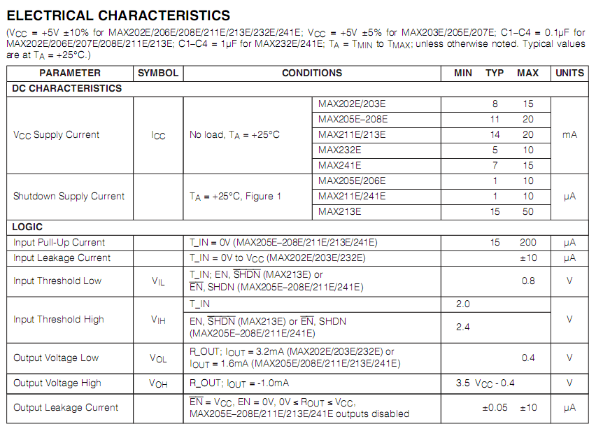

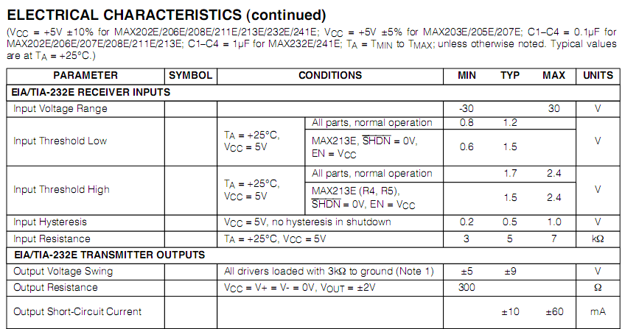 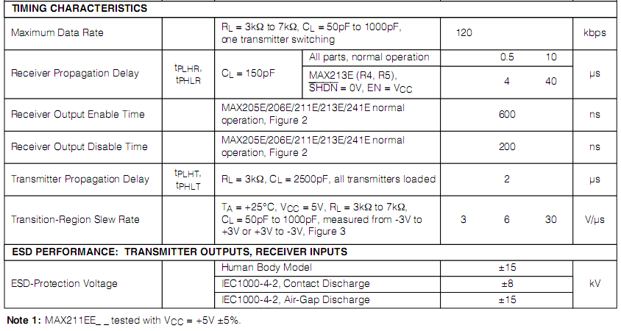

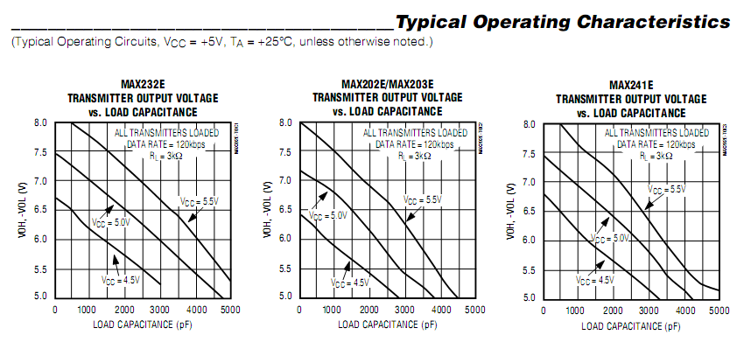 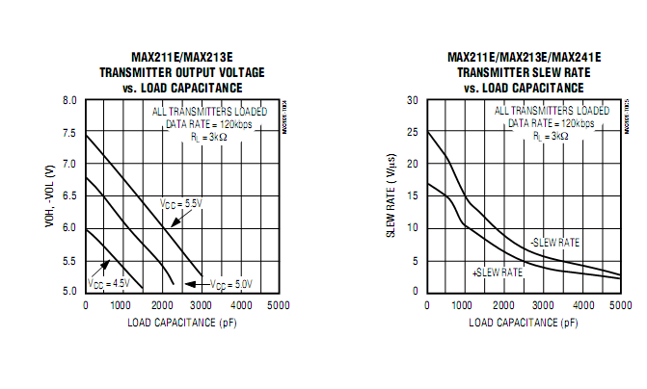

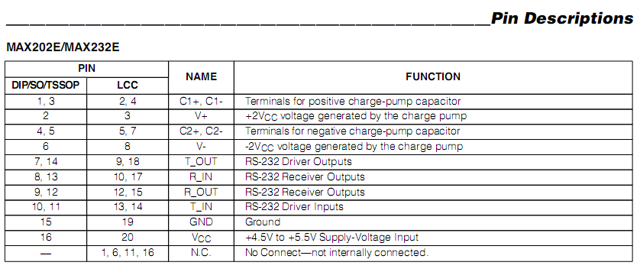

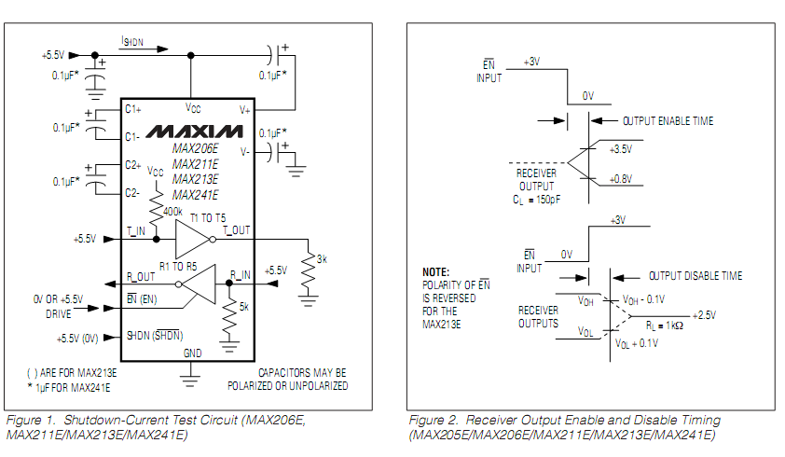

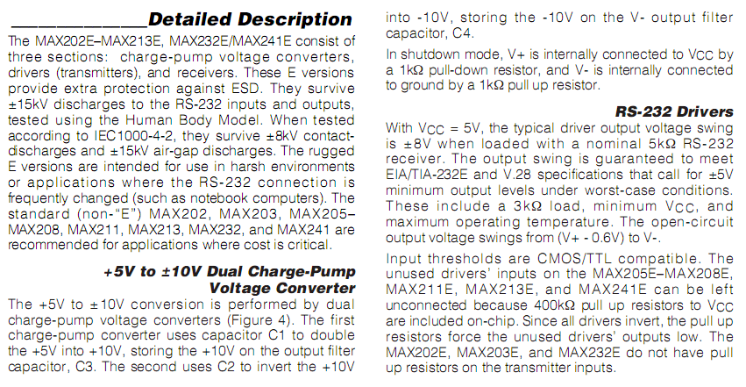

## lM 7805

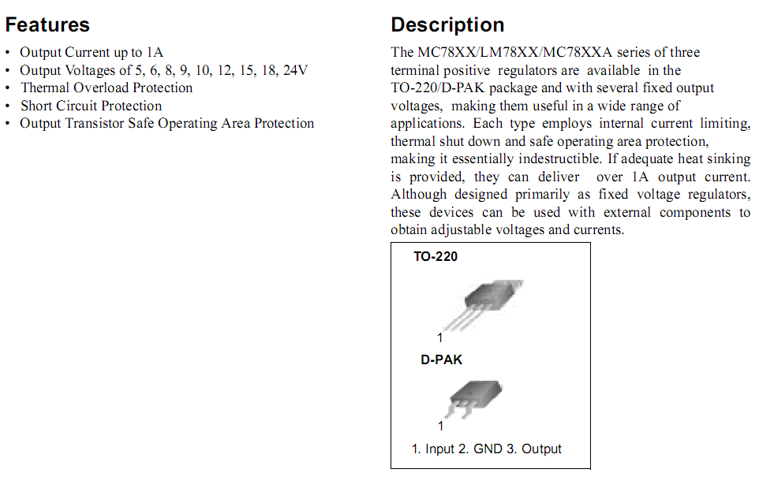

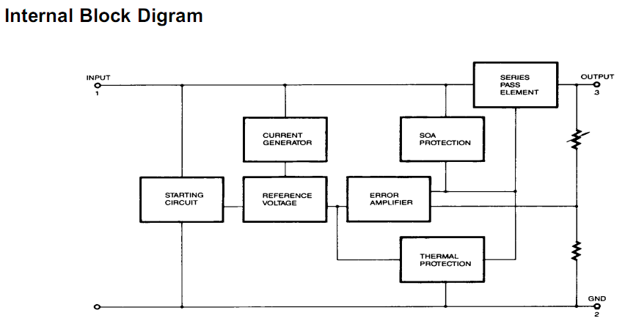

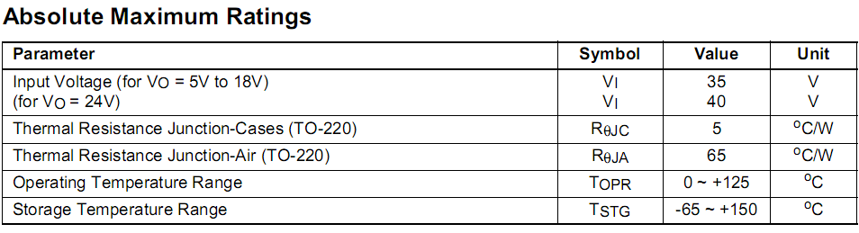

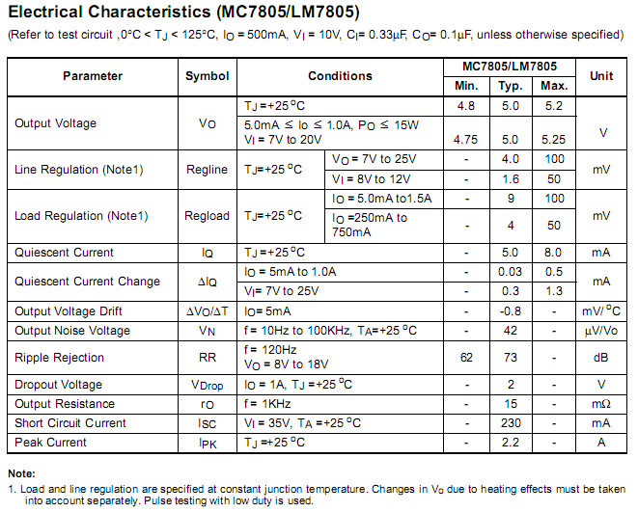

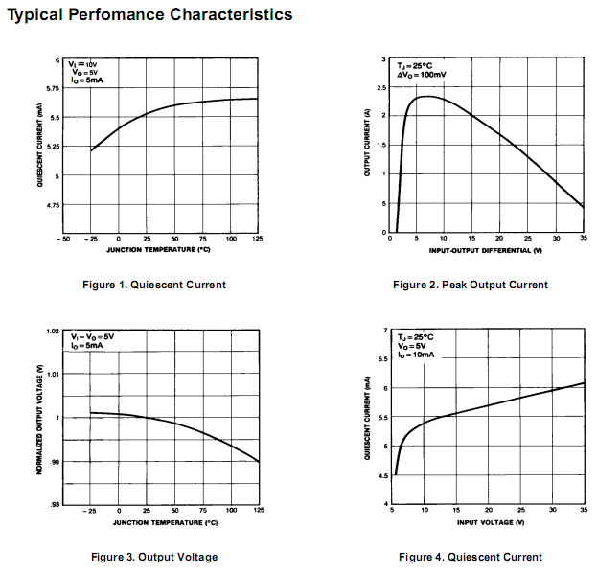

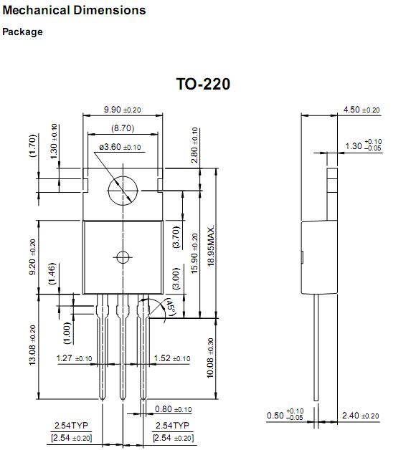

# Project hardware schematics

## Serial interface

### MAX232 Serial level converter

Max 232 
level converter**When communicating with various micro processors one needs to convert the RS232 levels down to lower levels, typically 3.3 or 5.0 Volts.**

Here is a cheap and simple way to do that.

**Serial RS-232** (V.24) communication works with voltages -15V to +15V for  high and low. On the other hand, **TTL** logic operates between 0V and +5V . Modern low power consumption logic operates in the range of 0V and +3.3V or even lower.

|  |  |  |
| --- | --- | --- |
| **RS-232** | **TTL** | **Logic** |
| -15V …  -3V | +2V … +5V | High |
| +3V … +15V | 0V … +0.8V | Low |

This level converter uses a **Max232** and five **capacitors**. The max232 is quite cheap (less than 5 dollars) or if youre lucky you can get a free sample from **Maxim.**

The MAX232 from **Maxim** was the first IC which in one package contains the necessary drivers and receivers to adapt the RS-232 signal voltage levels to TTL logic. It became popular, because it just needs one voltage (+5V or +3.3V) and generates the necessary RS-232 voltage levels.

#### The required parts:

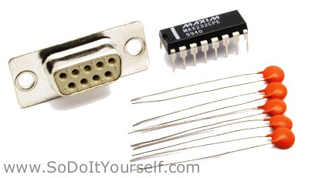

* 1 x female serial port connector
* 1 x max 232
* 4 x 1uF capacitor
* 1 x 10uF capacitor
* Soldering iron, wires, breadboard etc.

### Schematic

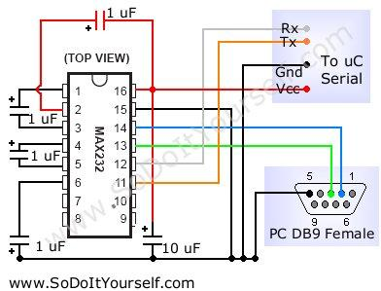

### Simple 5V power supply for digital circuits

**Summary of circuit features**

* Brief description of operation: Gives out well regulated +5V output, output current capability of 100 mA
* Circuit protection: Built-in overheating protection shuts down output when regulator IC gets too hot
* Circuit complexity: Very simple and easy to build
* Circuit performance: Very stable +5V output voltage, reliable operation
* Availability of components: Easy to get, uses only very common basic components
* Design testing: Based on datasheet example circuit, I have used this circuit succesfully as part of many electronics projects
* Applications: Part of electronics devices, small laboratory power supply
* Power supply voltage: Unreglated DC 8-18V power supply
* Power supply current: Needed output current + 5 mA
* Component costs: Few dollars for the electronics components + the input transformer cost

#### Circuit description

This circuit is a small +5V power supply, which is useful when experimenting with digital electronics. Small inexpensive wall tranformers with variable output voltage are available from any electronics shop and supermarket. Those transformers are easily available, but usually their voltage regulation is very poor, which makes then not very usable for digital circuit experimenter unless a better regulation can be achieved in some way. The following circuit is the answer to the problem.

This circuit can give +5V output at about 150 mA current, but it can be increased to 1 A when good cooling is added to 7805 regulator chip. The circuit has over overload and therminal protection.

[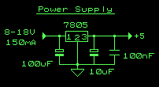](http://www.tkk.fi/Misc/Electronics/circuits/psu_5v.gif)  
*Circuit diagram of the power supply.*

The capacitors must have enough high voltage rating to safely handle the input voltage feed to circuit. The circuit is very easy to build for example into a piece of veroboard.

[picture 
of 7085 regulator](http://www.tkk.fi/Misc/Electronics/circuits/7805.gif)  
*Pinout of the 7805 regulator IC.*

* 1. Unregulated voltage in
* 2. Ground
* 3. Regulated voltage out

### Other output voltages

If you need other voltages than +5V, you can modify the circuit by replacing the 7805 chips with another regulator with different output voltage from regulator 78xx chip family. The last numbers in the the chip code tells the output voltage. Remember that the input voltage muts be at least 3V greater than regulator output voltage ot otherwise the regulator does not work well.

# Operational Modes

Operational mode is the mode of a system, subsystem, or component that is installed in its intended environment. The system executes in two operational modes.

## Normal Mode

This allows routine tasks to be performed.

## Emergency Mode

Advance mode to handle emergency situation. Gets started by clicking red emergency button.

# C:\Users\Ehmad\Desktop\flowchart.jpgApplication flowchart

# Application Architecture

The following components architect the GANGWAY CONTROL& SECURITY SYSTEM:

1. Physical hardware, a stationary web cam and fingerprint scanner
2. Algorithms
3. Database backend
4. A user interface

## Hardware

### Hardware Component

#### Hardware module

* Microcontroller (8051)
* MAX 232
* ULN 2308
* LM7805 Voltage Regulator
* Power supply using LM7805
* Cross Match Finger print verifier

### Microcontroller:

The Intel 8051 is a Harvard architecture, single chip microcontroller (µC) which was developed by Intel in 1980 for use in embedded systems.

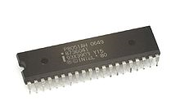

#### Features

1. 8-bit ALU, Accumulator and 8-bit Registers; hence it is an 8-bit microcontroller
2. 8-bit data bus - It can access 8 bits of data in one operation
3. 16-bit address bus - It can access 216 memory locations - 64 KB (65536 locations) each of RAM and ROM
4. On-chip RAM - 128 bytes (data memory)
5. On-chip ROM - 4 kByte (program memory)
6. Four byte bi-directional input/output port
7. Two 16-bit Counter/timers
8. Two-level interrupt priority

### ULN2803 (Current buffer IC)

The eight NPN Darlington connected transistors in this family of arrays are ideally suited for interfacing between low logic level digital circuitry (such as TTL, CMOS or PMOS/NMOS) and the higher current/voltage requirements of lamps, relays, printer hammers or other similar loads for a broad range of computer, industrial, and consumer applications. All devices feature open–collector outputs and free wheeling clamp diodes for transient suppression. The ULN2803 is designed to be compatible with standard TTL families while the ULN2804 is optimized for 6 to 15 volt high level CMOS or PMOS. MAXIMUM RATINGS (TA = 25°C and rating apply to any one device in the package, unless otherwise noted.)

### MAX 232

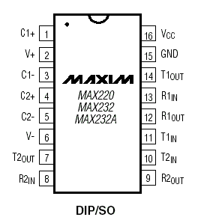

The MAX232 is an [integrated circuit](http://en.wikipedia.org/wiki/Integrated_circuit) that converts signals from an [RS-232](http://en.wikipedia.org/wiki/RS-232) serial port to signals suitable for use in [TTL](http://en.wikipedia.org/wiki/Transistor-transistor_logic) compatible digital logic circuits. The MAX232 is a dual driver/receiver and typically converts the RX, TX, CTS and RTS signals.

The drivers provide RS-232 voltage level outputs (approx. ± 7.5 V) from a single + 5 V supply via on-chip [charge pumps](http://en.wikipedia.org/wiki/Charge_pump) and external capacitors. This makes it useful for implementing RS-232 in devices that otherwise do not need any voltages outside the 0 V to + 5 V range

### LM7805 VOLTAGE REGULATOR

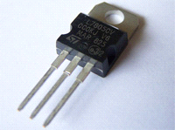Voltage regulator is a three legged device. Having one i/p one o/p and a ground. 12 volts are coming at the i/p and 5 volts are produced at o/p. This is used to reduce 12v to 5v so it can be used by microcontroller

## PC

We have developed this software using following hardware:

###### A DELL Vostro Laptop

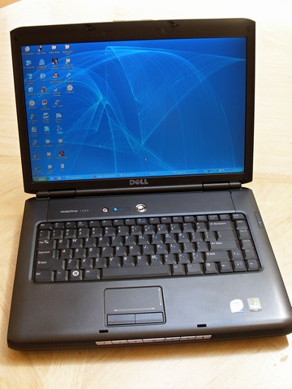

###### An old CREATIVE webcam

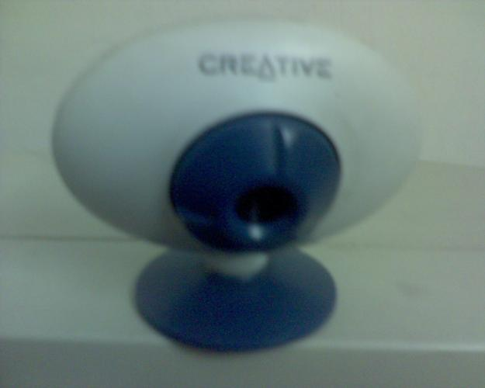

###### CrossMatch Verifier® 300 LC 2.0

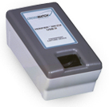

##### Note:

As mentioned in hardware specification, our software is not limited to these specific devices. For details see hardware specification.

# Algorithms

## Application Algorithm

Initialize Main Form (pseudo-code):

1. Initialize camera.
2. Initialize finger print reader.
3. Get video stream from camera via USB (serial) port.
4. If C fails, go to A else E.
5. Set picture box to display video stream.
6. Set Database Path;
7. Open Database.
8. If G fails, go to I else J
9. Create database.
10. Get User’s records from database;
11. Fill list box with User IDs on Main Form.
12. Set Focus to very first record in the list box.
13. Set labels with details of selected user.
14. We can make the differentiation between officers and sailors at the time of enrolment.
15. It will be with respect to the numbers:
16. The officers have numbers as 7177. Etc (Like they are of 4 digits )
17. While sailor have numbers in 6 digits as 123456. Etc (Like they are of 6 digits)
18. And for civilians, we will be using only digits like 01, 02 , 03 .. Etc. (Like they will be of 2 digits )
19. Therefore, all the numbers greater than 999 and less than 9999 will be considered as officer.
20. The numbers greater than 99999 and less than 999999 will be considered as sailors.
21. The numbers greater than 00 and less than 99 will be considered as civilians.

### Implementation:

1. The counter function will count the id’s titled between the respective group:
2. For total present strength, all the officers and sailors registered who didn’t sign off, will be counted by the counter function.
3. The total number of registered ships company will then be subtracted from the present state which will give the state of absentees.
4. The officers will be counted as per their P.No and the same goes for the sailors i.e 4 digits list for officers absentees and 6 digits list for sailors absentees.
5. The id of the personnel on leave will be given the extension of 8 digits or above i.e 1111 will be added before their number.
6. They will be counted on leave, i.e all numbers greater than 10000000 will be displayed and counted as on leave.
7. In the list with name section, the forms of the files counted as away will be displayed i.e their profile will be displayed.
8. Profile for all the personnel will be maintained by taking string i.e input from the user or operator in a new form which will be saved with respect to their P.No ,etc.

VeriFinger 6.2 algorithm is being used in our application for finger print verification. For our system and modules works as follow:



## VeriFinger algorithm

The software functionality is based on a simplified version of VeriFinger algorithm. The SDK allows reading fingerprints from scanners and performing fingerprint verification (1:1 matching) only. Quality control can be applied to accept only good quality fingerprints from fingerprint scanners.

## Process flow

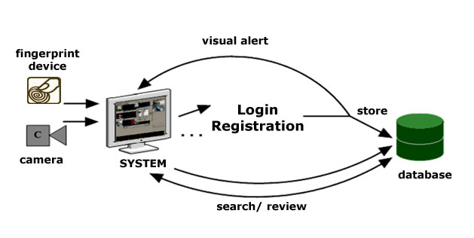

# Database

As mentioned above, the database system in use is MS ACCESS. This section will provide details about how data is being organized using tables and some queries to get an understaning how we

## Tables

There are following four tables in our database:

1. Crew – About onboard members (Officers, Sailors and civilions etc)
2. Ranks – The possible type of people allowed in ship
3. TimeLog – The attendance register
4. appSetings – Software configuration table

### Crew

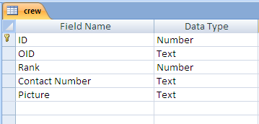

The crew table contains records about the crew member. The minum details are being used for efficency whereease the addititional details can be obtained using OID that’s the specific unique ID in navy records about the particulor person. The picture field contains the path of picture file on local hard disk.

### Ranks

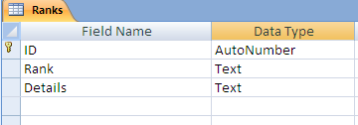

This table is linked with crew table and it contains the details about member rank in navy. The rank field is the title field and ID is unique identifier in this table.

### TimeLog

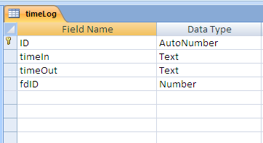

This table is like digital attendance register that contains sign in and sign out timing of all members.

### appSetings

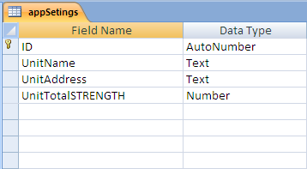

This table is a configuration table used to store setting about software system.

## Entity Relationship Diagram

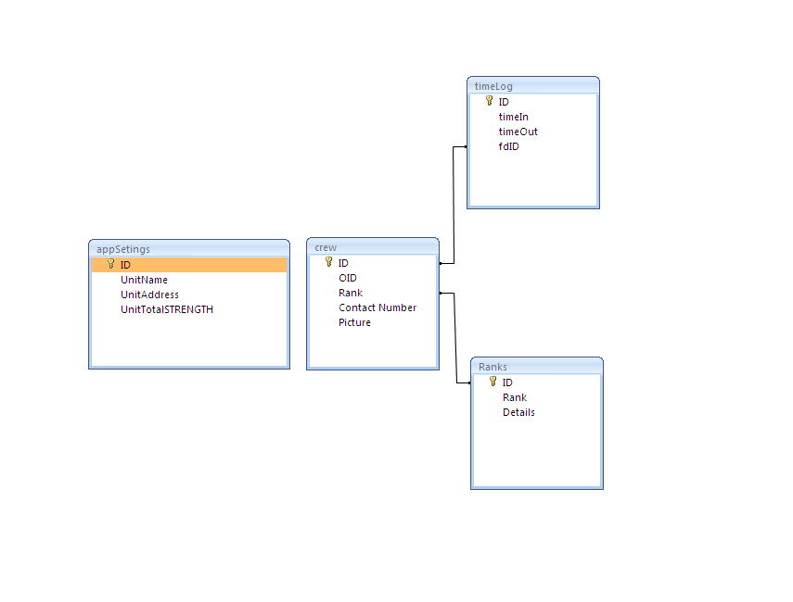

## Fingerprint enrollment/verification module

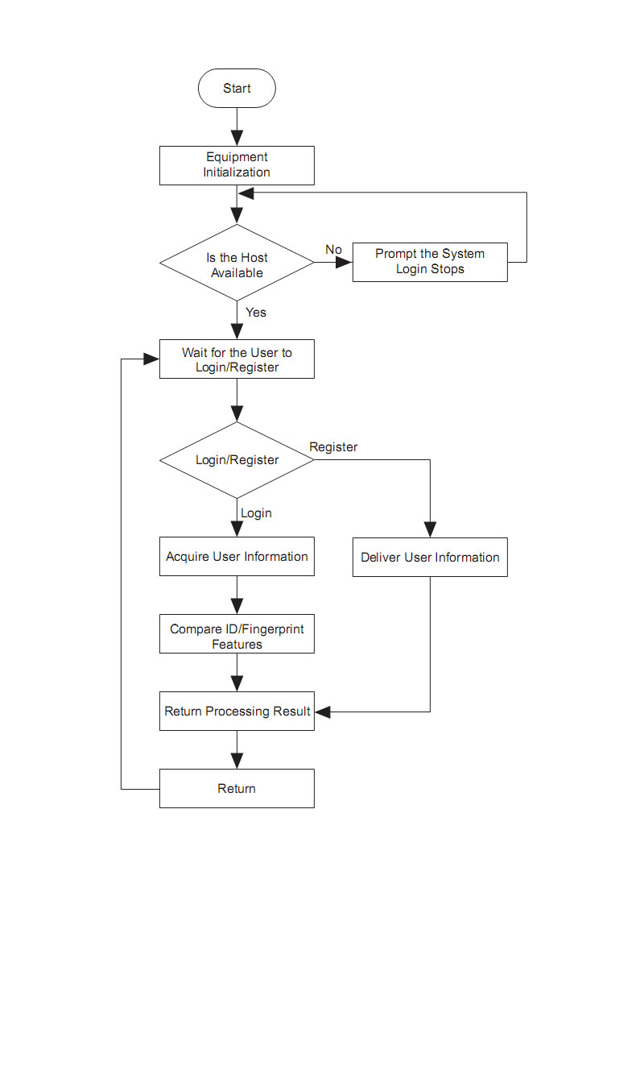

# Class diagram

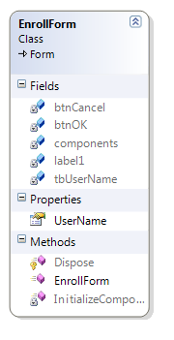

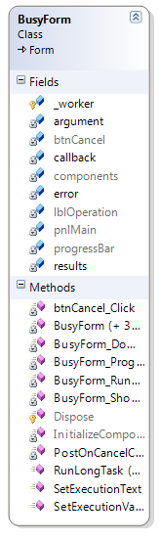



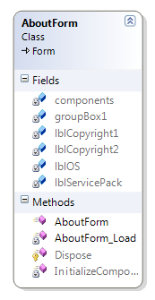

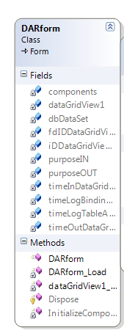

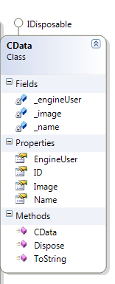

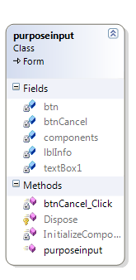

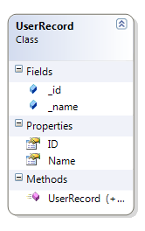

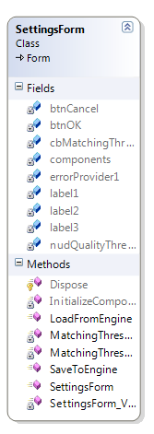

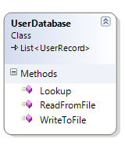

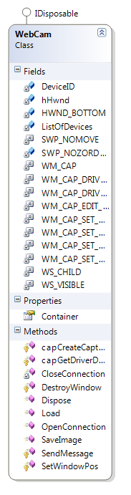

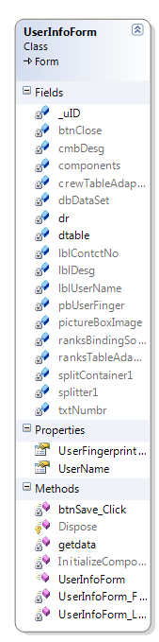

## Dataset

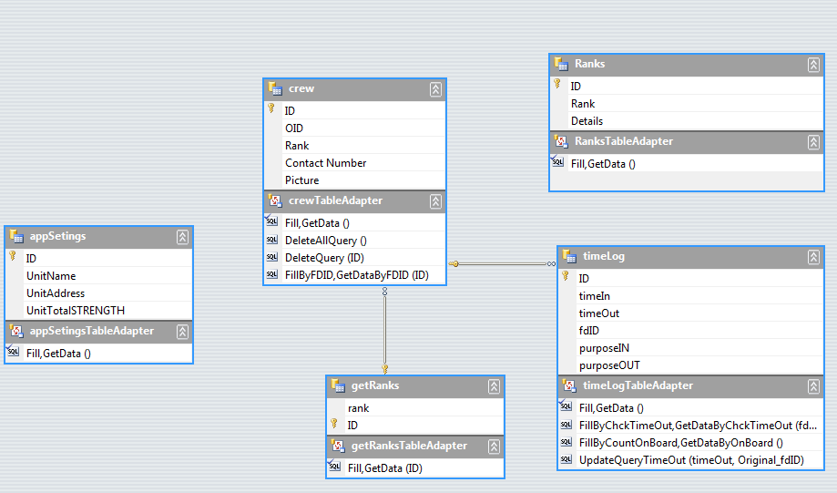

# Screenshots

## Main window

The User interface is very user friendly. The main window shows the number of staff members on board with date/time and unit name.

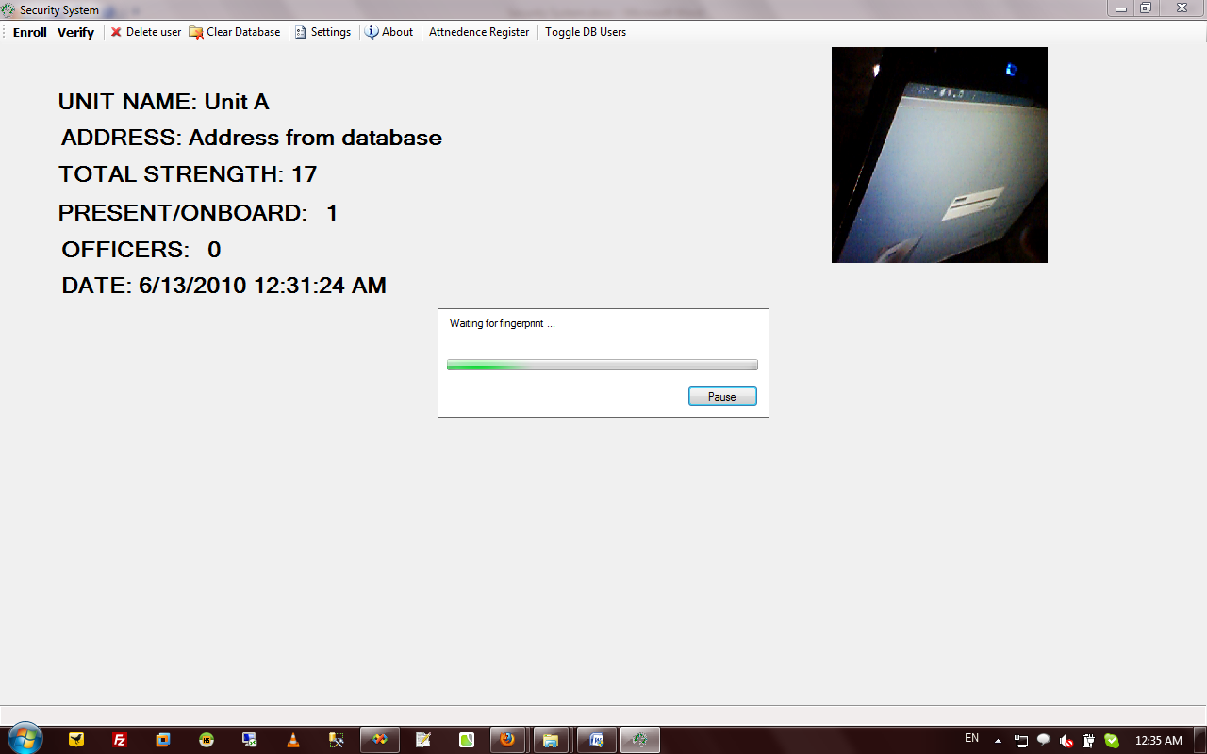

## User Information Form

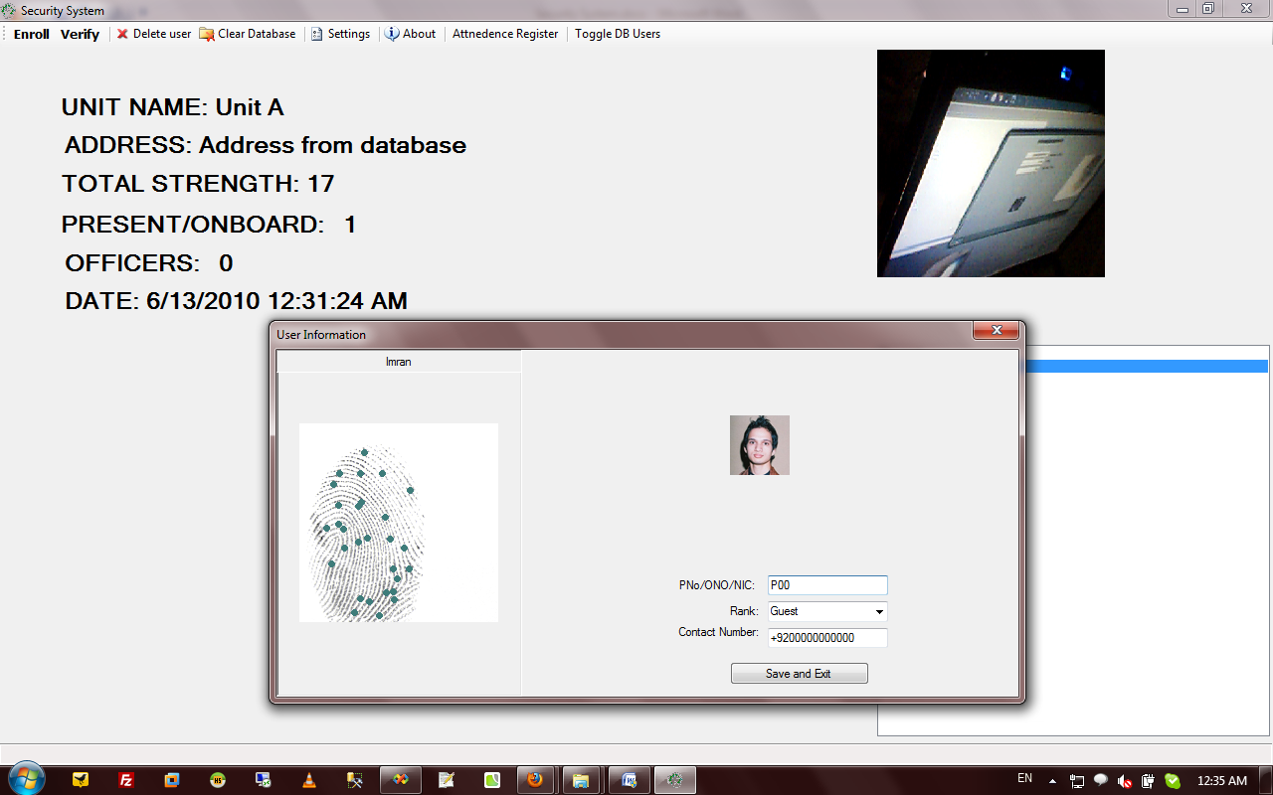

## Signing IN/Out

## Administration window

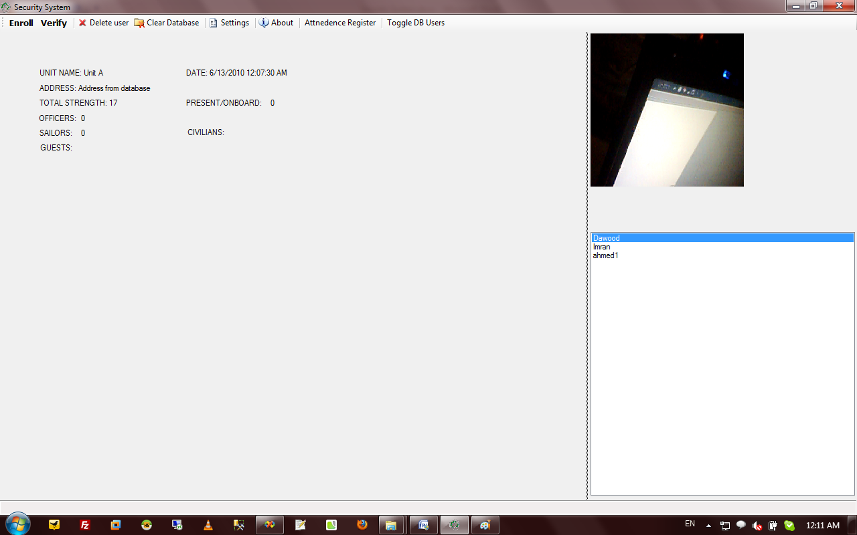

## Attendance report

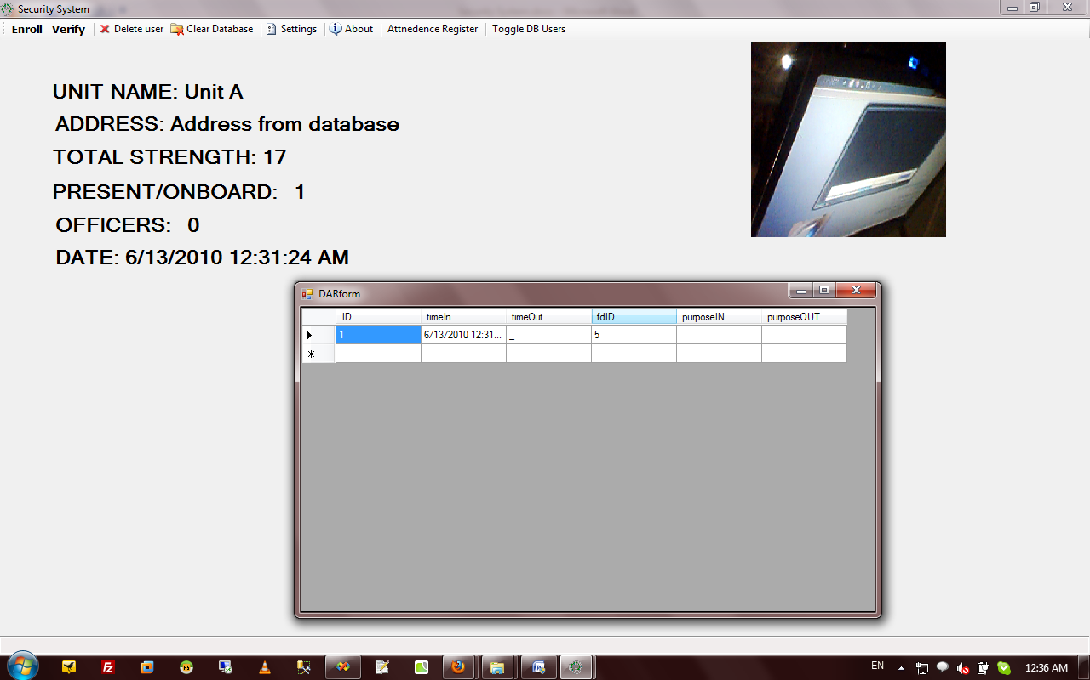

# Testing and Implementation

Several tests were carried out with respect to the thumb detection and they were successful. We have tried to design system capable of handling PN ships environments. We hope that we have achieved that target.

# Conclusion

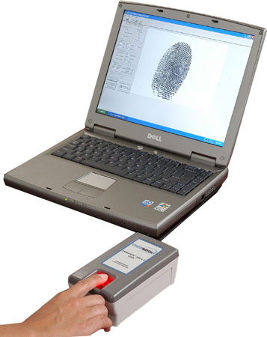 It was a great learning experience throughout our last semester. We have definitely learned a lot from this project. The application has been fully tested and is in working state. The application is in state to be deployed on PN ships.

# References

# APPENDICES

## APPENDIX A

### MICROCONTROLLER CIRCUIT DIAGRAM WITH PORTS

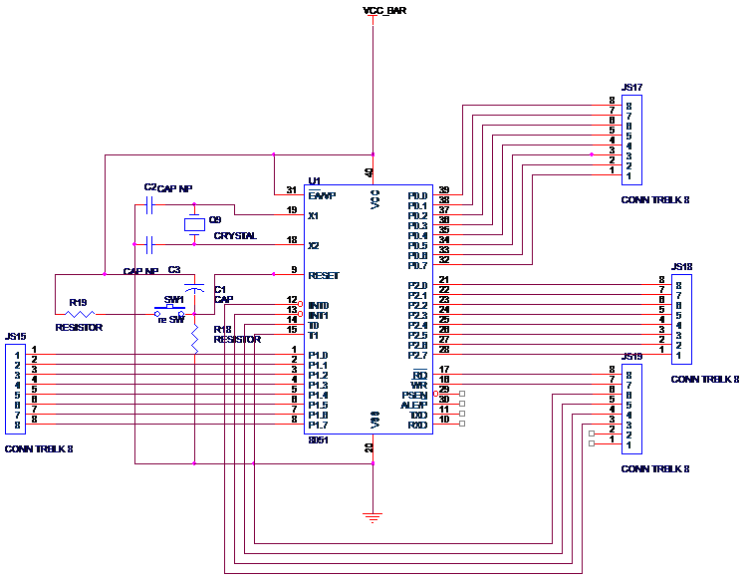

### Serial Interfacing

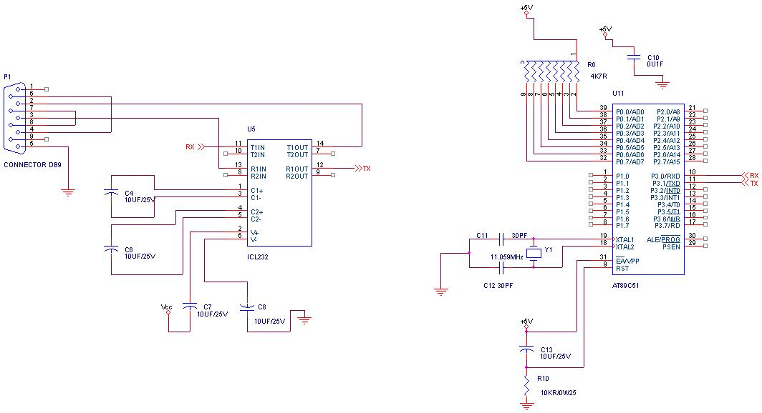

## APPENDIX C

### STATEBOARD CODE (ASSEMBLY LANGUAGE)

INCLUDE 89C51.MC

;---------------------MAX232-------------------------------

; Register definitions.

rBUFFER EQU 00h ; read data register

wBUFFER EQU 01h ; send data register

;----------------------------------------------------------

(0000H):

JMP on_reset

;-----------------------Serial Interrupt-------------------

(0023H):

JNB RI,ser_down

MOV rBUFFER,SBUF ; read data

CLR RI

JMP int_end

ser_down:

MOV SBUF,wBUFFER ; send data

CLR TI

int_end:

RETI

;----------------------------------------------------------

(00FFH):

on_reset:

;Initialize Timer

;Baud rate table

;Fosc = 11.0592 MHz

;Baud rate TH1 TH1(hex) SMOD(PCON.7)

;300 160 A0 0

;1200 232 E8 0

;2400 244 F4 0

;4800 250 FA 0

;9600 253 FD 0

;19200 253 FD 1

;28800 255 FF 0

MOV TH1,#FDH ; baud rate 9600

MOV TMOD,#20H ; timer-1 in 8-bit auto reload

MOV SCON,#50H ; receive enable

CLR PCON.7 ; SMOD = 0

; MOV IE,#90H ; Serial Interrupt 10010000b

ENDLESS:

CALL get_byte

MOV A,rBUFFER

MOV wBUFFER,A

CALL send_byte

JMP ENDLESS

;----------------------------------------------------------

;Without interrupt

;----------------------------------------------------------

send_byte:

MOV SBUF,wBUFFER ; send data

SETB TR1

RS232BACK: JNB SCON.1,RS232BACK ; wait for TI

CLR TF1

CLR SCON.1

RET

;----------------------------------------------------------

get_byte:

SETB TR1

RS232B: JNB SCON.0,RS232B ; wait for RI

MOV rBUFFER,SBUF ; get data

CLR TF1

CLR SCON.0

RET

;-----------------------------------------------------------

## APPENDIX D

### Block Diagram

